REPORT ON BAÑUELOS DE BUREBA MEETING OF 2019 TO COMMEMORATE THE 50TH ANNIVERSARY OF THE FIRST STAGE ON FREINET PEDAGOGY CARRIED OUT IN SANTANDER IN 1969.
From May 31 to June 2, 2019, the 50th anniversary of the first meeting of Freinetian teachers after the Civil War, which took place in Santander, in 1969, was celebrated at the Antoni Benaiges School in Bañuelos de Bureba, Burgos.
The conference has been organized by the Spanish Freinet Movement (MCEP) and the Escuela Benaiges Association of Bañuelos de Bureba (AEB). This union represents the continuity of our own pedagogical history that we want to claim.
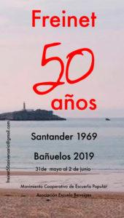
We remembered the evolution from the first teachers who introduced Freinet pedagogy in our country, among them the members of the Batec Group, Josep Alcobé, Patricio Redondo, José de Tapia, Dolors Piera, José Casamajó, Ramón Costa Jou, Ana Gavín and so many others, and the teacher of Bañuelos, killed during the Civil War, Antoni Benaiges, until the creation, in the last years of the dictatorship, of the Association for Correspondence and School Printing (ACIES), which was in the origin of the current Popular School Cooperative Movement- MCEP, which has already celebrate 46 annual congresses with the last one in Huelva on July 2019.
It all started in the course 1962-63, when the teacher Ferran Zurriaga, who was as provisional in a graduate school in Llíria, Valencia, initiated a school correspondence with a French companion, Christiane, of the village of Saint Marcial de Mirambeau. In that school of Llíria, Ferran met with Roser Santolaria, who would be a great activist and they will always collaborate since then. Little by little, Freinet’s message was shifting, and Ferran transmitted it to the teachers of Valencia, in the group called "Lo Rat-Penat": Enric Tàrrega, Paco Codonyer, Pilar Calatayud, Carme Miquel, Josep Pitarch, Josep Pla…
On Easter 1966, the group attended the XXII Congress of the Modern School in Perpinyà. From that contact with ICEM, with the CEL and with some of Freinet's collaborators, such as M. Linares, Bertran and the teachers of French Catalonia, the Modern School Movement was going to be part of the educational activity of the Valencia group since then. During the 1969-70 academic year, they left the Lo Rat-Penat society and became known as Grup Freinet de València (1969-1972).
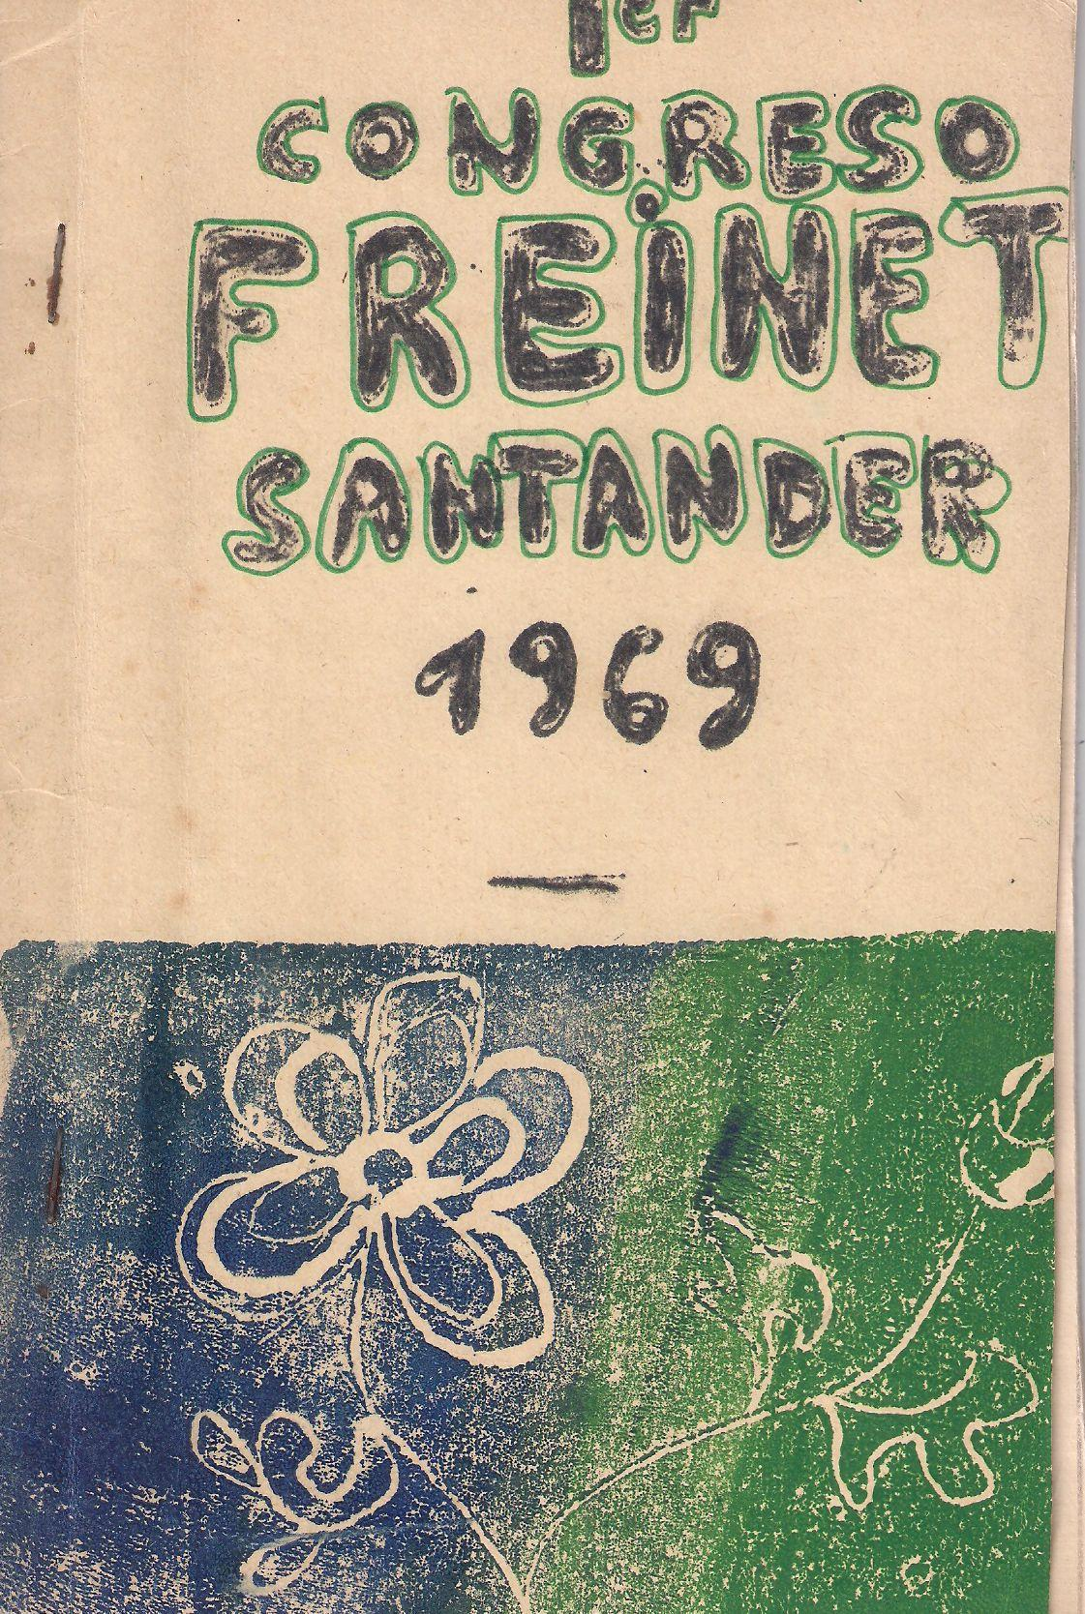
In August 1969, the first Peninsular “Stage” on Freinet pedagogy after the Civil War, organized by Ferran Zurriaga, was held at the Torreblanca school, located in a villa in Sardinero, Santander. About fifty people from different parts of the peninsula met: Andorra, Álava, Asturias, Vizcaya, Catalunya, France, Guipúzcoa, Madrid Navarra, Santander and Valencia. From Andorra came Josep Alcobé, an enthusiastic teacher of the Spanish II Republic who became President of the International Federation of Modern School Movements, FIMEM, and then Honorary President of the Cooperative Movement of Popular School, MCEP.
For several days they talked about Freinet but, above all, they practiced their techniques in an environment and a personal relationship of companionship that was like a dream for all the people who participated.
There is no doubt that this meeting meant a methodological improvement in their practices and a deepening of their social commitment.
Elise Freinet knew the meeting, and sent a message full of memories of that moment of her life in which she hosted a group of Spanish children refugees from the war of 1936-39 at the Freinet de Vence School. She declared in the message:
“The joy of Freinet would have been great in front of this typically Iberian spirit assembly, as I have already said, I had acquired the conviction that spontaneity, dynamism and intuitive sensibility, which are the marks of your instructional heritage, are also the very basis of the natural method of education”.
In June 1971, Triunfo magazine, through Alfonso Carlos Comín, published an extra issue dedicated to "El Niño, that stranger" (No. 472. June 19, 1971), in which an article by Ferran Zurriaga appeared:
"A teacher of school. Freinet's liberating pedagogy". That number of Triumph served so that numerous teachers connected with Freinet pedagogy and many of them were integrated into the groups that later gave rise to the future Territorial Groups (GT), created from the authorization, in May 1974, of the Spanish Association for Correspondence and School Printing (ACIES).
For many teachers it was as if they discovered a way of being in the world, while they became aware of their obligation as educators: free expression, communication, correspondence, were ways of life valid for everyone, both for children as for adults ... One of the things that encouraged them the most in the spread of that pedagogy was the difference between Freinet and the famous educators of the European New School.
Freinet was a teacher who started from daily practice, he had not limited himself to telling teachers the best way to live the classroom, but also that it was necessary to cooperate with each other, so that together they would bring about the pedagogical and social renewal that the new Times demanded. Most of the teachers who lived this stage were teachers in the public school, except in Catalonia, Euskadi and in other places such as Santander, where there was a growth of schools created by parents and groups of teachers in form of cooperatives.
In 1977, at the IV Congress of Modern School, which was held during the month of July in Granada, the general assembly, after a long debate, agreed to change the name of ACIES into "Popular School Cooperative Movement, MCEP".
Since then, the MCEP has been considered the "official" representative of the Freinet pedagogy throughout the territory of the Spanish State.
BAÑUELOS DE BUREBA MEETING PROGRAM
Friday, May 31:
Reception from afternoon/evening. Some people arrived on Saturday, so the complete reception must be done before 10 in the morning.
Saturday 1 June:
10:00. Visit to the Benaiges School.
10:30 Presentation of the Conference.
1st. Welcome words from the mayor.
2nd. Presentation of the Conference from the organizing Commission.
11:00 Conference on the first steps during the sixties, including the Santander stage, by Ferrán Zurriaga.
12:00. Coffee break.
12:30 What we have done since then.
1st. Paper on the Batec group, Sebastián Gertrúdix
2nd. Roundtable: The teachers of the transition; the current situation of Freinet pedagogy, with the participation of Fabricio Caivano, Carmen Agulló, Alfred Ramos, Anamari García, Julio Rogero, Javier Rueda and Xusa Alemany. Javier González introduced it and Enrique Pérez moderated the roundtable.
2:30 p.m. Lunch.
17:00. Workshop: Writing a free text, coordinated by Sebastián Gertrúdix.
18:30. Benaiges and the Association. Presentation of the box with the reproduction of school newspapers and special editions of the National Mixed School of Bañuelos de Bureba, "Escritos de Vida", by José Antonio Abella. Presentation of the biographical booklet "Antonio Benaiges Nogués", by its author, Ignacio Soriano.
7:30 p.m. Screening of the documentary “Deshabitados” by Hugo Atman.
20:30 End of the day: Dinner
Party: Performances by Manel Gil-Inglada & Ramón Sauló.
Sunday, June 2:
10:30 Presentation of the book "El mar será...", by the authors, Sebastián Gertrúdix and Sergi Bernal.
11:30 Freinet today.
Talk debate: "The role of the university in the dissemination of modern pedagogy", with the participation of Marta García, Dean of the Faculty of Education of the University of Cantabria; Ignacio Fernández de Mata, Dean of the Faculty of the University of Burgos; Sara Ramos, of the Department of Educational Studies Faculty of Education-Complutense University of Madrid; Teresa Rabazas, Director of the Museum of Education History "Manuel Bartolomé Cossío" and the Complutense Textile Pedagogical Collection Complutense University of Madrid.
The debate is moderated by Olga Meng, Director of the Infant School of the University of Cantabria.
1:30 p.m. Formal farewell with coffee...
VALUATION OF THE PAPERS
On Saturday, June 1, at 11 in the morning, Ferran Zurriaga was relenting his commitment to Freinet pedagogy and how it has been adding followers over the years, starting from the 1969 Santander Stage, once that its expansion was interrupted by the result of the civil war in 1939.
At 12:30 Sebastián, presented by Tere Flores, told us about the Batec group from Lleida (in Spanish, heartbeat), informing us about the main components of it and how they created the Printing Cooperative in the School, celebrating the first two congresses of the same in Lleida (1934) and Huesca (1935). The third was going to be in Manresa, but the Civil War prevented it.
Then, the round table was held to analyze the current situation of Freinet pedagogy, in which Fabricio Caivano, Carmen Agulló, Alfred Ramos, Anamari García, Julio Rojero, Javier Rueda and Xusa Alemany, moderated by Enrique Pérez and presented by Javier Gonzalez. They reviewed some of the most outstanding experiences on Freinet pedagogy carried out since the sixties of the last century, until today.
The situation of various investigations that are being carried out to recover and give visibility to many teachers who applied these techniques throughout the twentieth century and whose experiences are not known or recognized as they deserve was also reported.
In the afternoon a writing workshop was held, coordinated by Sebastián Gertrúdix, in which all the participants were able to take a photo or a drawing on some corner of the class or Bañuelos and write a postcard addressed to the teacher. With all of them a book will be prepared that will be sent, in digital form, to the participant persons in the conference.
At 18:30 the box was presented with the booklets that the teacher Benaiges published with his students, under the title "Writings of life", by José Antonio Abella. This presentation was very successful, and the majority of attendees reserved a copy. However, the biographical booklet "Antonio Benaiges Nogués", written by Ignacio Soriano, is being more controversial. A commission has been created for a deeper study to present a critical report on the text and write a new biography. "
At 19:30 it was planned to screen the documentary “Deshabitados”, but it was suspended due to lack of time, at the proposal of Enrique Pérez, a member of the organizing committee.
On Sunday, day 2, at 10:30 the novel "El mar será..." was presented, by its authors, Sebastián Gertrúdix and Sergi Bernal, presented, in turn, by Teresa Flores. The novel recreates the life of maestro Antoni Benaiges in Bañuelos de Bureba, from his arrival until his arrest and subsequent murder.
At 11:30 a talk-debate took place with the title "Freinet today", in which representatives of the universities of Santander, Burgos, Madrid, the Museum of Education History "Manuel Bartolomé Cossío" and the Pedagogical Collection Textile from the Complutense University of Madrid, moderated by Olga Meng, discussed the current situation of Freinet pedagogy in the university and the levels of cooperation between educators of different educational levels. It was found that, despite some examples in various places such as Madrid, Burgos, Santander, Lleida, Murcia ..., the degree of collaboration of Freinetian educators with those of university levels should be much more intense and frequent, so we will try, between Everyone, may this wish be fulfilled in the future.
Regarding the present and the future of Freinet pedagogy, we will end with some of the words Ferràn Zurriaga spoke in his lecture:
“The pedagogy of Master Freinet is for the school of today and tomorrow. Our presence here, in the school of the teacher Antoni Benaiges, is an affirmation of its validity. In the school of today and of the future, the knowledge and research in a cooperative environment will constitute the basis and condition for integral school change. And an asset of our movement is internationalism, represented in the International Federation of the Modern School Movement (FIMEM). It is a fundamental principle of Freinet pedagogy, respect for the identity of each culture and each people, without forgetting to denounce discriminatory cultural practices. A sample of its reality is the "Letter of 2008" adapted to the current moment, a letter that shows the cooperative work of all its members to achieve common goals. And in it we discover that the transversal idea that unites them remains cooperation. And we continue working. We have been fortunate to see the transformation of our society, to continue maintaining pedagogical principles that are still useful for many students, classmates. Virtually all those Freinet techniques that we use can be said to be applicable now; Far from being obsolete, they are still necessary.
As Francesc Imbernon says in his book "Les invariants pedagogiques i la pedagogia Freinet" cinquanta anys després, (2010):
“to the current pedagogical kitchen, there is always some ingredient of Freinet pedagogy”.
Its application helps to modernize the school, it implies starting from the child's experience and its free expression. Through active and critical research on reality, children develop greater security, autonomy and self-confidence and, in teachers, an active approach to their profession, lifelong learning and educational cooperation. Cooperation remains a necessary word for any human work; It is the effort of each to meet in the other and to take initiatives in order to receive their response. Freinet taught us to learn from the past and think about the future, with courage; We can also do better, with the commitment to social and political freedoms.
The current world has many challenges: the situation of women, the issue of the rural world and its depopulation, climate change, technological invasion, insolvency between countries, poverty in society ...
All this asks us for courage. In this story of teachers there is a lot of courage. In many moments we have had weak points, but if we move with a noble passion and our trade is, it is possible to have courage despite our shyness and get the help of others. Together we can change the world".
Cooperative Movement of Popular School - MCEP.

