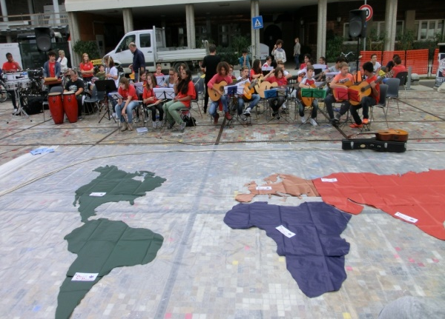

TO THE BD OF THE FIMEM
TO THE MOVEMENTS OF MODERN SCHOOL- FREINET PEDAGOGY
The MOVIMENTO DI COOPERAZIONE EDUCATIVA (MCE) , which has always adhered to THE FIMEM and is committed to the dissemination of Freinet pedagogy in Italy and with solidarity projects in various parts of the world, finds itself in a moment of great difficulty. The Municipality of Rome has given eviction to all the associations that occupy public offices even with a regular contract.
We have to leave our small national headquarters, a place for meetings, training, exchanges, cooperative research. We have no other solution but to commit all our strength and energy to buy a location that we have found, even if decentralized.
We need your help to purchase the office that commits all the resources that the Italian movement can have and requires to take out a bank loan and to appeal to the solidarity of members, and supporters.
That's why we opened a crowdfunding. Till now we have collected € 653, The objective is € 15.000, the date we have to respect is 6th March , 2019
You can make your donation large or small by clicking on
https://www.retedeldono.it/it/progetti/movimento-di-cooperazione-educativa/ponte-dincontro
Leave us your good wish phrase that will be published.
The new headquarters will be a meeting place open to everyone, including meetings of the CA and Fimem groups with whom we collaborate. An archive in which to gather the educational experiences of an active school, from Mario Lodi to Paul Le Bohec, from Gianni Rodari to don Lorenzo Milani, from Emma Castelnuovo to Paulo Freire.
Giancarlo Cavinato MCE national secretary

